First step in certainty assessment: Choosing between random effects and fixed effect models
An important choice Core GRADE users conducting systematic reviews will face is whether, in their analysis, to use fixed effect or random effects statistical models. Fixed effect ignores variability in results across studies.
Random effects considers that variability and generates wider confidence intervals the greater the variability. Thus, the key points to know about the choice of model is the following:
- When little heterogeneity exists (I² at or near 0) fixed effect and random effects models will yield very similar results.
- With substantial heterogeneity there will be two differences between the models:
  - The confidence interval will be wider in random models
  - If the small and larger studies yield different results the point estimate in the fixed will reflect the results in the larger studies to a greater extent than random models.
Statisticians disagree about the merits of the two approaches and there is no right answer regarding which to use. An article suitable for Core GRADE users provides details about the approach ¹ and we present the key issues below.
When heterogeneity is substantial, the models will yield different results. In particular, confidence intervals will
typically be wider in random effects and the gradient in weight between large and small studies will be greater in fixed effect models. The result will be that point estimates in fixed effect models will be closer to the large study results than point estimates in random effects model.
The figure below presents three hypothetical meta-analyses.¹ In A there is very little variability and so fixed and random models yield the same pooled estimates. In B there is considerable variability and so the random model produces a considerably wider confidence interval. However, because all studies are a similar size and weight (depicted by the same width confidence interval) the point estimates from the two models are identical. In C
there is again high heterogeneity and so the confidence interval is wider for the random model. Here though, the small and large studies have different results and so the random point estimate is closer to the small studies than the fixed.
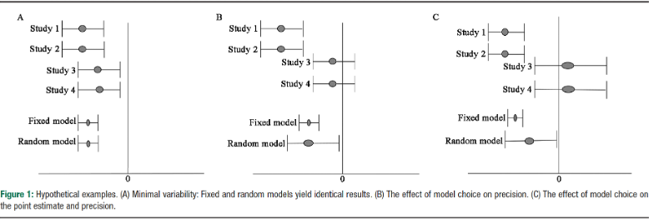

The figure below presents actual meta-analysis illustrating the three situations: A with very little variability and so the same pooled estimates; B with large variability and so wider confidence intervals with random models but because of similar magnitude of effect in large and small studies very similar point estimates; and C with both
large variability and difference in magnitude of effects between large and small studies and so differences in both pooled point estimates and width of their confidence intervals.

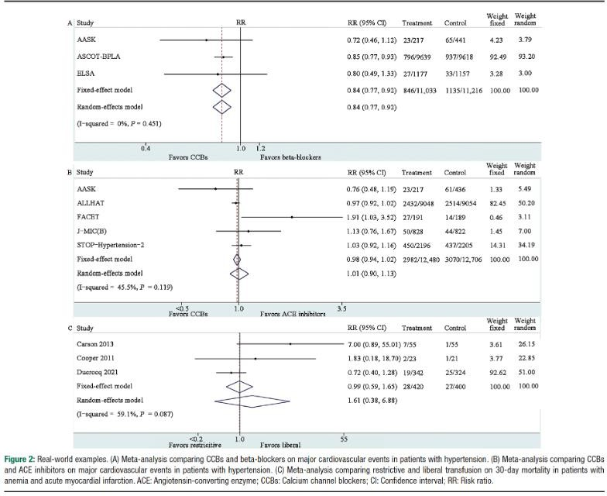

Possible advantages of random effects models over fixed effect
- In theory random effects models accept that true effects differ between studies (fixed does not) and tries to estimate an effect in all possible studies (fixed effects just tries to estimate the effect in the included studies). Many find these theoretical considerations more appealing for random effects.
- Intuitively, the more the variability in results between studies, the less certain we are about the pooled estimates of effects. Random effects reflect these uncertainties while fixed effect does not.

Possible advantages of fixed effect models over random effects
- The gradient in weight between large and small studies is larger in fixed than random models. Since we tend to trust larger studies more than smaller studies, the greater weight that random gives to smaller studies might be perceived as a limitation.
- In particular situations when there are large differences between large and small studies random effects sometimes yields results that are not credible.
- Since, when there is appreciable heterogeneity, random effects confidence intervals will be wider there is a greater possibility of rating down for imprecision. Thus, in GRADE, when heterogeneity is large, random effects risks double-counting inconsistency in study results: one rates down for inconsistency and then again for precision given the wide confidence intervals driven by the heterogeneity of results.

Reference
1. Zhai C, Guyatt G. Fixed-effect and random-effects models in meta-analysis. Chin Med J (Engl) 2024;137(1):1-4. doi: 10.1097/cm9.0000000000002814 [published Online First: 20230823]

